1.

A if_icmpeq1 MAR = SP = SP – 1; rd Read in next-to-top world of stack

if_icmpeq2 MAR = SP = SP – 1 Set MAR to read in new top-of-stack

if_icmpeq3 H = MDR; rd Copy second stack word to H

if_icmpeq4 OPC = TOS Save TOS in OPC temporarily

if_icmpeq5 TOS = MDR Put new top of stack in TOS

if_icmpeq6 Z = OPC - H If top 2 words are equal, goto T, else F

B TOS will be replaced in the next cycle, so the content needs to be saved in a temporary cycle.

If note copied into cycle 6, we use TOS instead of OPC in cycle 6, which will give us a wrong calculation.

2.

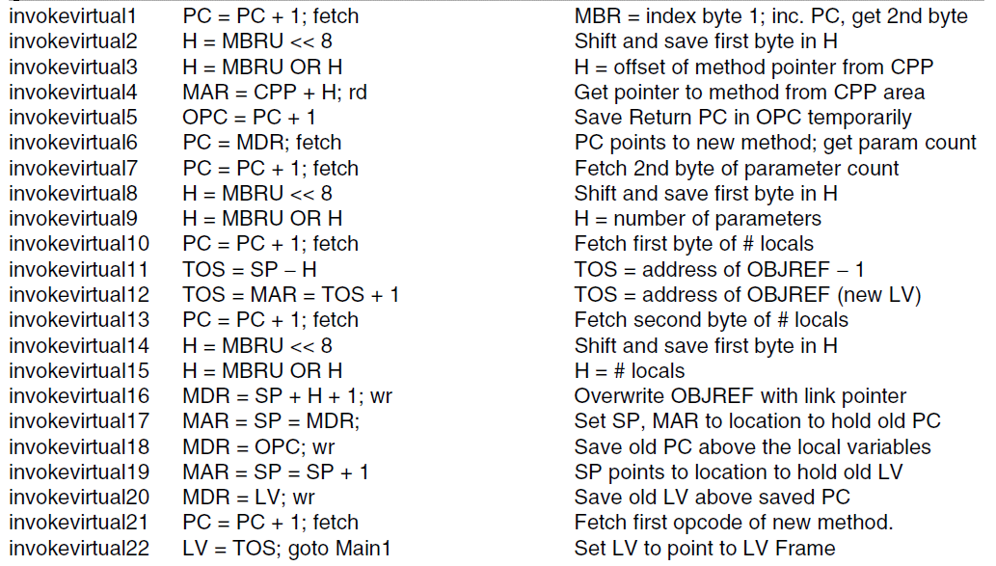

Takes 21 instructions to call one integer, therefore we need a loop to execute 2 more loops. Total instructions needed to execute 3 parameters will be (21 * 3 = 63 instructions + 2 for loops instructions = 65 instructions).

CPUtime =

However, CPI and clock rate is unknown so we can’t determine CPUtime